Task Support

Digital Signatures

**Latest Revision: 02/23/2024**

Purpose

Provide guidance on how to use a Digital Signature or Adobe Sign to sign PDF documents.

Significant Information

Multiple digital signatures can be placed on a PDF document, but the PDF document cannot be altered once it is digitally signed.

***Designation of Beneficiary forms can be signed with a digital signature, but all signatures must be completed in the same manner.***

# Signing a PDF Document with a Digital ID

|  |  |
| --- | --- |
| 1. Open the Portable Document Format (PDF) to be signed in Adobe Desktop. | |
| 1. Select “Tools” from the menu bar. |  |
| 1. Under “Forms & Signatures”, click “Certificates”. |  |
| 1. A new menu bar toward the top of the screen will appear. Select “Digitally Sign” from the menu bar. |  |
| 1. In the area to be signed, outline a box for the signature. 2. Perform one of the following: | |  |  | | --- | --- | | **If you need to:** | **Then:** | | **Select a Digital ID** | Select your ID and click continue. | | **Configure New Digital ID** | 1. Click “Configure New Digital ID.” 2. Select the type of Digital ID. 3. Save the ID to Windows Certificate Store. 4. Enter your identity information for the self-assigned Digital ID. 5. Click Save. 6. Select your digital signature and click “Continue”. | |
| 1. Select “Sign”. |  |
| 1. When the dialogue box opens, save the form to your computer. |  |
| 1. If applicable, enter a passcode to continue. |  |
| 1. Your PIV Card Signature and Date will appear in the form as shown in the example. |  |

**You will follow this process each time you need to sign.**

# Signing a Document with Adobe Sign

1. Open the Portable Document Format (PDF) to be signed in Adobe Desktop.
2. Select “Tools” from the menu bar.  
     
   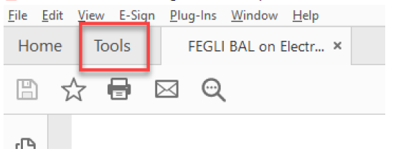
3. Under “Forms & Signatures”, click “Fill & Sign”.
4. A new menu bar toward the top of the screen will appear. Select “Sign Yourself” from the menu bar.   
   

|  |  |
| --- | --- |
| **If:** | **Then:** |
| You previously saved a “scanned signature” | It will appear. |
| You do not have a signature available for use | Select “Draw” icon to sign using your mouse/stylus or select the image document if you have a scanned signature available for use on your computer. |

***Note****: For retirement documents, do not use the “Type” feature as it is not an approved electronic signature option. for retirement documents.)*  
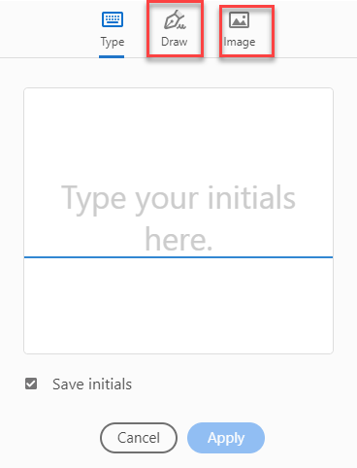

1. Select Apply.

# References / Resources

* [Title 5, Code of Federal Regulations (CFR) 850.106](https://www.law.cornell.edu/cfr/text/5/850.106) allows electronic signatures on forms related to federal retirement and benefit programs.