# Generating NIH Supervisory CLP Transcript Report in LMS for My Staff

## Who can run this report? Managers & Supervisors with Direct Reports

1. Log on to the LMS (<http://lms.learning.hhs.gov>)
2. Select the Team Icon in e header. It looks like a group of people.
3. On the left side, select, **Reports**.

With reports highli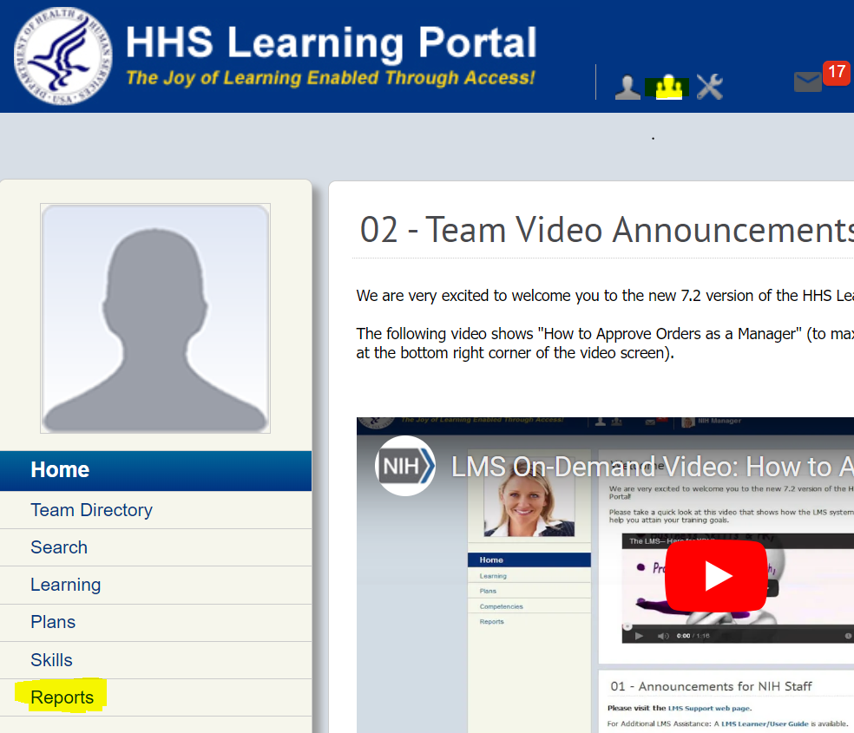

1. In the Name field, enter **NIH CLP** and select **Search**.
2. In the **Actions** column, select **Actions** 🡪**Execute**.

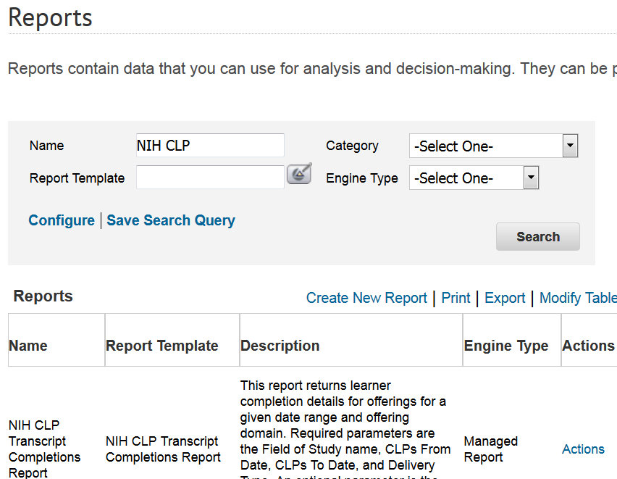

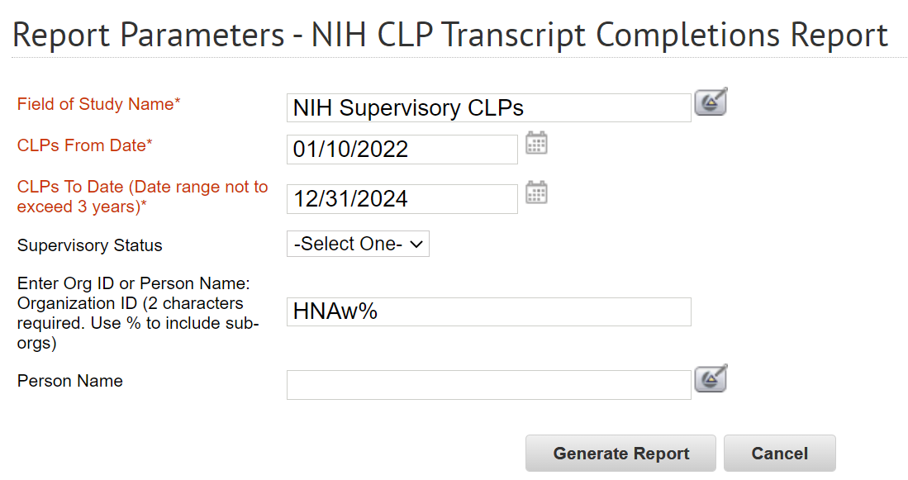

1. Enter the following criteria for the required parameters:
   1. **Field of Study Name** = NIH Supervisory CLPs
   2. **CLPs From Date** = 01/01/2022
   3. **CLPs To Date** = 12/31/2024
   4. **Org Code** = (This is your IC’s SAC code. You can be specific or broad. Add a percent sign to view all staff in the selected HNAW SAC code. For example, all staff in DPCPSI would be HNAW%)
   5. **Person’s Name** = optional field
   6. **Supervisory Code** = optional field
2. Select **Generate Report**.
3. Exporting the Report
   1. After the report pops up the report tuns, select the 4th button on the toolbar – Export this Report

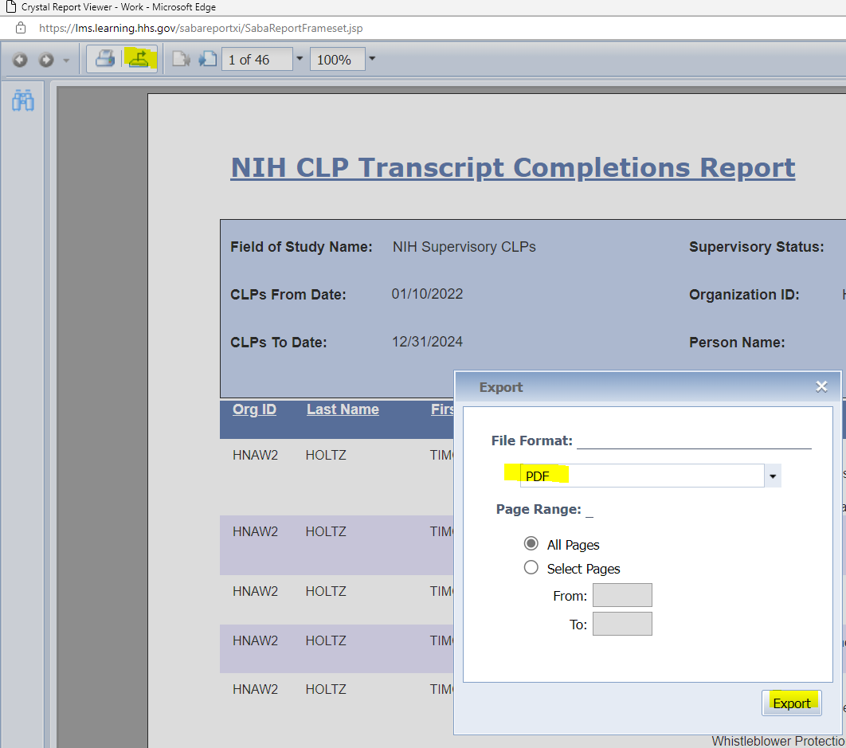



# NIH Supervisory Reporting in the LMS

# Subscribe to the NIH CLP Transcript Completions Report

1. Log on to the LMS (<http://lms.learning.hhs.gov>)
2. Select the Team Icon in e header. It looks like a group of people.
3. On the left side, select, **Reports**.
4. In the Name field, enter **NIH CLP** and select **Search**.
5. In the **Actions** column, select **Actions** 🡪**Subscribe**.



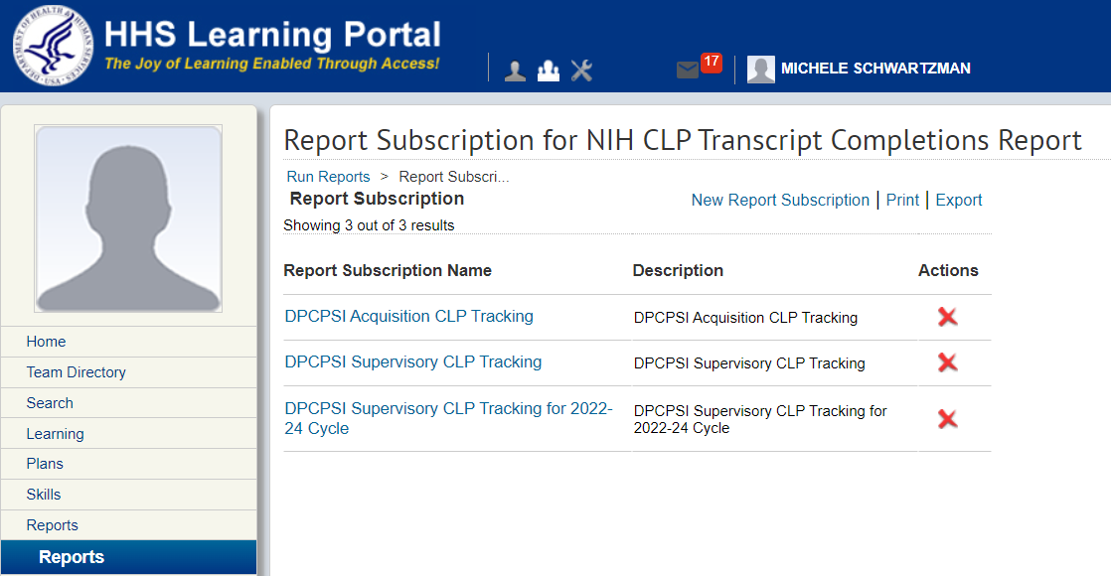

1. Select the “**New Report Subscription**” link. Located just right of center on the screen.
2. Enter the following criteria for the required parameters and note that there is a screenshot of the parameters on the next page.
   1. **Report Subscription Name** = Supervisory CLP Report for My Team
   2. **Description** = Supervisory CLP Report for My Team
   3. **Field of Study Name** = NIH Supervisory CLP
3. Press Tab and the LMS will automatically update this field as “NIH Supervisory CLPs”
   1. **CLPs From Date** = Select “**Fixed Date**”
4. **Enter Date =** 01/01/2022
   1. **CLPs To Date** = Select “**Fixed Date**”
5. **Enter Date =** 12/31/2024
   1. **Supervisory Status** = optional
   2. **Org Code** = (This is your IC’s SAC code. You can be specific or broad. Add a percent sign to view all staff in the selected HNAW SAC code. For example, all staff in DPCPSI would be HNAW%)
   3. **Person’s Name** = optional field
   4. To = enter email address
   5. **Subject** = Supervisory CLP Report for My Team
   6. **Mail Text =** enter text for the body of your email
   7. **Report Format** = Select either **Acrobat Format (PDF)** or **Microsoft** **Excel Workbook (Data-only)**
   8. Exporting to PDF for easier viewing. If exported to Excel, there will need to be data cleanup to analyze.
   9. Occurs = Select whether the report frequency should be Daily, Weekly or Monthly
      1. For example, if you select Monthly, you can then decide you want to see it every month, every 2 months, etc… AND on what day of the month
   10. **Frequency** – Select **Once**
   11. **Start Time** = please use a time between 12 AM and 7 AM
   12. **Start Date =** When you want the report to begin
6. After all the parameters are set, select **Preview Report.** Either your PDF or Excel worksheet will display.
7. Once satisfied, select **Save** Now, just wait for the emails to begin.

