# NIH Supervisory CLP Reporting

# Generating the NIH CLP Transcript Completions Report

## Who can run this report? LMS Administrators

1. Log on to the LMS (<http://lms.learning.hhs.gov>)
2. Select the Admin Icon (wrench/screwdriver) in e header. All Administrators can complete this task.
3. On the left side, select, **Reports**.
4. In the Name field, enter **NIH CLP** and select **Search**.
5. In the **Actions** column, select **Actions** 🡪**Execute**.

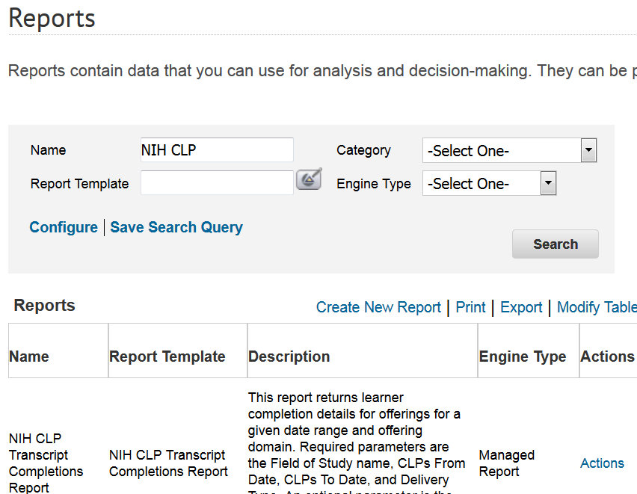

1. Enter the following criteria for the required parameters:
   * **Field of Study Name** = NIH Supervisory CLPs
   * **CLPs From Date** = 01/01/2022
   * **CLPs To Date** = 12/31/2024
   * **Org Code** = (This is your IC’s SAC code. Add a percent sign to view all staff in the selected IC. For example, OD would enter HNA% in this field.)
   * **Person’s Name** = optional field
   * **Supervisory Code** = optional field
2. Select **Generate Report**. Then, export to PDF for easier viewing. Export to PDF.