# Generating My NIH CLP Transcript Report in LMS

1. Log on to the LMS (<http://lms.learning.hhs.gov>)
2. Select the **My Learning** Icon in e header. It looks like a single person.
3. On the left side, select, **Reports**.

1. In the Name field, enter **NIH CLP** and select **Search**.
2. In the **Actions** column, select **Actions** 🡪**Execute**.

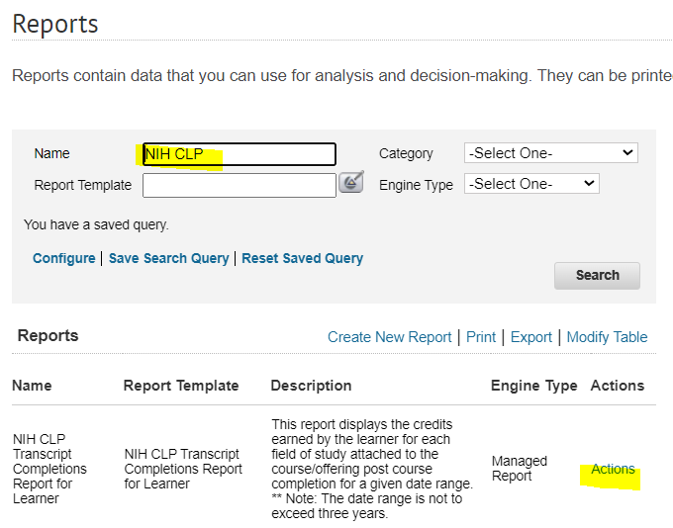

1. Enter the following criteria for the required parameters:
   1. **CLPs From Date** = 01/01/2022
   2. **CLPs To Date** = 12/31/2024

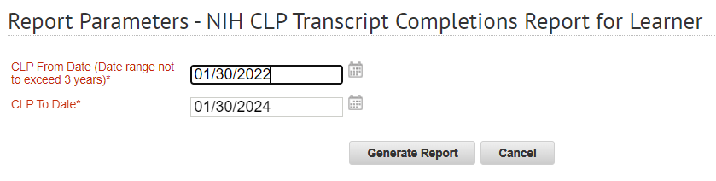

1. Select **Generate Report**.
   1. Note that this report will display a summary of each type of NIH CLP (NIH Acquisitions AND NIH Supervisory) that you have achieved. Look for the NIH Supervisory CLP section.

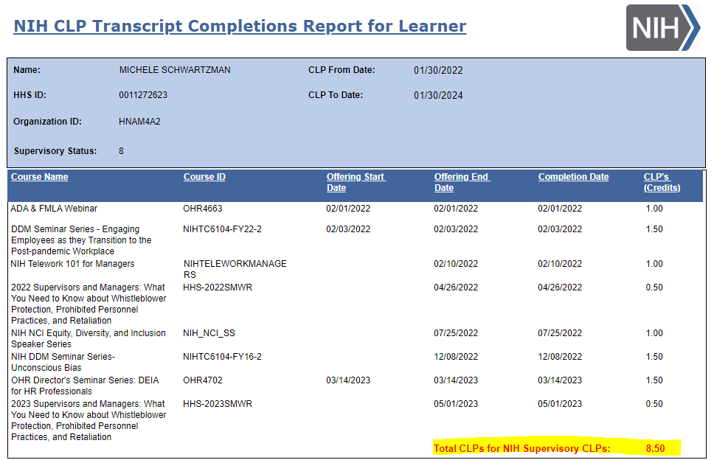

1. Exporting the Report
   1. After the report pops up the report tuns, select the 4th button on the toolbar – Export this Report.

