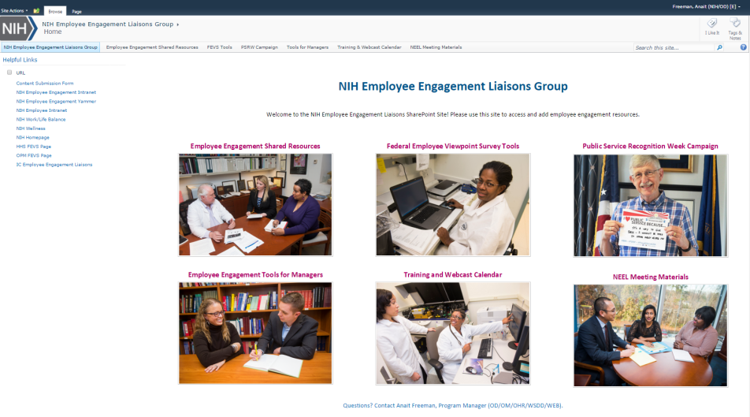
About
Launched in July 2015, the NIH Employee Engagement Liaisons Group (NEEL) SharePoint Site provides workforce management staff the necessary resources and tools to enhance employee engagement activities, share best practices and increase collaboration across the Institutes and Centers (ICs).

Website Resources
- Employee Engagement Shared Resources: Features a list of articles, books and webcasts on employee engagement and helpful action planning resources
- Federal Employee Viewpoint Survey (FEVS) Tools: Provides a list of tools to help your IC promote the survey and increase participation in order to gather feedback that will help ensure the NIH excels at providing a safe, effective, and engaging workplace for all employees.
- Public Service Recognition Week (PSRW) Campaign: Includes a list of tools to help your IC promote the PSRW campaign by building a positive image of government service and the work each NIH employee performs to advance NIH’s mission.
- Employee Engagement Tools for Managers: Lists tools to help managers better understand their employees’ recognition and feedback preferences while also providing them strategies for giving constructive feedback and minimizing conflict in the workplace.
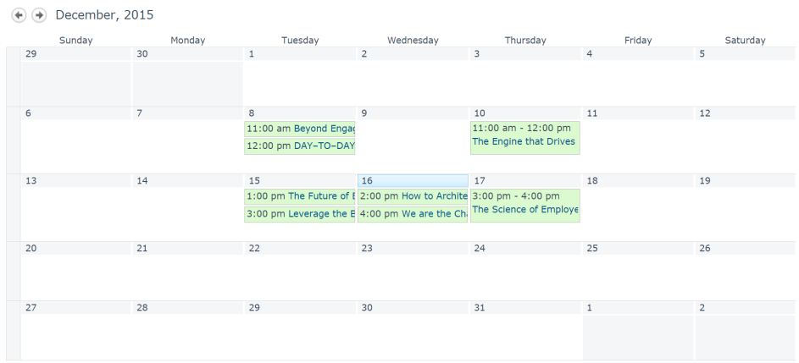
- Training and Webcast Calendar: Provides regularly updated calendar with training and development opportunities for employees related to employee engagement and workforce planning.
- NEEL Meeting Materials:
Includes presentations, meeting agendas and other materials covered during the bi-monthly NEEL meetings.

SharePoint Site Access
To access the SharePoint site, go to https://ohr.od.nih.gov/NIHEngagement. To request access, please email Anait Freeman, anaitfreeman@nih.gov.

